Missile Defence System - ADLAS

Written by Simon Crowther

# Abstract

The Main aspect of this paper is to create, develop and test a missile defence system that will target incoming projectiles. Systems of this nature are often complex and perform high levels of algorithms to calculate correct values for ensuring absolute best performance. Moreover, designing a system of this nature will allow a certain level of understanding on how to map a system to requirements and ensure the re-usability.

The end goal of this project will enhance the understanding of how the system will cope with unexpected scenario’s and will affect the performance, once the system has been tested and then each possible scenario compared such as distance, altitude and angle of trajectory. All quality and event variables will have collected to be up and hence analysed to find a measure of performance that is useful in assessing the validity of the system tested and also to seek a final evaluation of what is happening.

**Keywords = Ada, Requirements, Traceability, V software lifecycle**

Contents

Abstract 2

Proteus Design 6

Problems solved so far 8

What I have learnt from this Project? 14

Conclusion 14

Appendix 16

# List of Abbreviations

# 

BS = Base Station

HLD = High-Level Design

LLD = Low-Level Design

SDLC = Software Development Life Cycle

# List of Figures

Figure 1: STM32 On Begin - Page 15

# 1 Introduction

## 1.1 Background

For this project, it was the idea to focus on an idea that has become very important in today's defense society. It has become apparent that missiles can be fired from any point of the earth and with the speed capabilities and high probability of not being able to destroy the object before it hits its intended target. I wanted to focus on something I found fascinating and to really look at how complex of a system of this nature would be and if it was capable of being miniaturized onto a STM32F4 board and coded in Ada 2012 which is a strongly typed language.

This system needs to calculate what values bout the other object is necessary to calculate the probability of nullifying the object and whether it would be possible within the timeframe of detecting to endpoint. Throughout this project, I will look at various software techniques used to work out the most efficient way of software development and if it’s possible to ensure that software quality can be maintained throughout the project.

## 

## 1.2 Aim

The overall focus of this project is to set requirements, design, implement and code a complex missile defense system.

## 1.3 Objectives

* Review theoretical aspects of software development
* Review components of missiles and counter measures
* Review ADA software
* Set requirements for the system
* Design and code the system
* Provide verification of software meeting requirements
* Perform system and unit testing
* Produce conclusions on the project

## 1.4 Design Points of Objectives

This section is to explain each objective and how it will be reached, it will then be reviewed in the last chapter Conclusion to see if it was completed.

* Review theoretical aspects of software development – Look at different SDLC models and which will fit this project suitably, understand how each one has its advantages and disadvantages.
* Review components of missiles and counter measures – Further review into physical aspects of missiles and how they operate, what measures can be used to counter and how current systems calculate choices.
* Review ADA software – Researching how Ada can be used to be safety and mission critical and aid the user to falling into similar coding pitfalls.
* Set requirements for the system –Create requirements for what the system should operate to and ensure that traceability of requirements to code is followed throughout.
* Design and code the system – Create the system required for main functionality to match the specification
* Provide verification of software meeting requirements – Ensuring that the code is fulfilling what it was designed to do.
* Perform system and unit testing – Ensuring the values and system performs the expected results
* Produce Conclusions for the project – Explain the positives and negatives for the project and whether the end product matched the design set out.

## 1.5 Methodology

This project will be using software called Riverbed Modeller and it will be used to create a series of networks that will be simulated with the Voice application to determine the most suitable performance. What was needed from this project was to understand the capabilities and limitations of each network and how they would compare as everyone is unique.

This method of simulation and experimentation using OPNET is one of the most efficient and very useful for visually seeing the data in graph form and allows comparison between scenarios for each network. The variables that was changed in each scenario network were different, for wired and wireless connections it could only be codec's and the amount of users per network.

Riverbed Academic Edition 17.5 was used to simulate the alternative networks that were built, Wired, Wireless, Mobility and UMTS. For each network the variables changed were slightly different, for example the wireless could not have its link to the router changed as it didn't require one unlike the wired network. It created synthetic voice traffic set in the voice application configuration whereby it would model duplex voice calls between users. It collected the voice data set specific data that was the data statistics which are explained in chapter 7.1, what is most useful is that it makes available the data for the usage on the network.

## 1.6 Report Outline

This report will explain all points that will be faced during the project. Studying what the performance will be affected by whether the codecs or amount of users utilised, this will give an overview of which network is better suited to the type. As this paper covers a limited amount of networks and codecs, it does not provide a complex view of all networks and codecs available; it could be seen as a taster. By completing this it will show which type ifs better placed for each network. Chapter 2 will give an overview of the technology on use, Riverbed will be explained in 2.1, VoIP and QoS in 2.2 and 2.3. Chapter 2.4 is a collection of the networks and their model designs that will be simulated, the tests vectors that are going to be used to calculate the quality of the calls being made on the networks.

Chapter 3 is the simulation setup for the Riverbed software where the details of how each of the software was set up, chapter 4 is the results collection with analysis of each test vector and then an in-depth analysis of comparisons between each of the networks. Chapter 5 is the concluding section where findings and sustainability and ethics will be explored, chapter 6 is the conclusion and any future developments for the project.

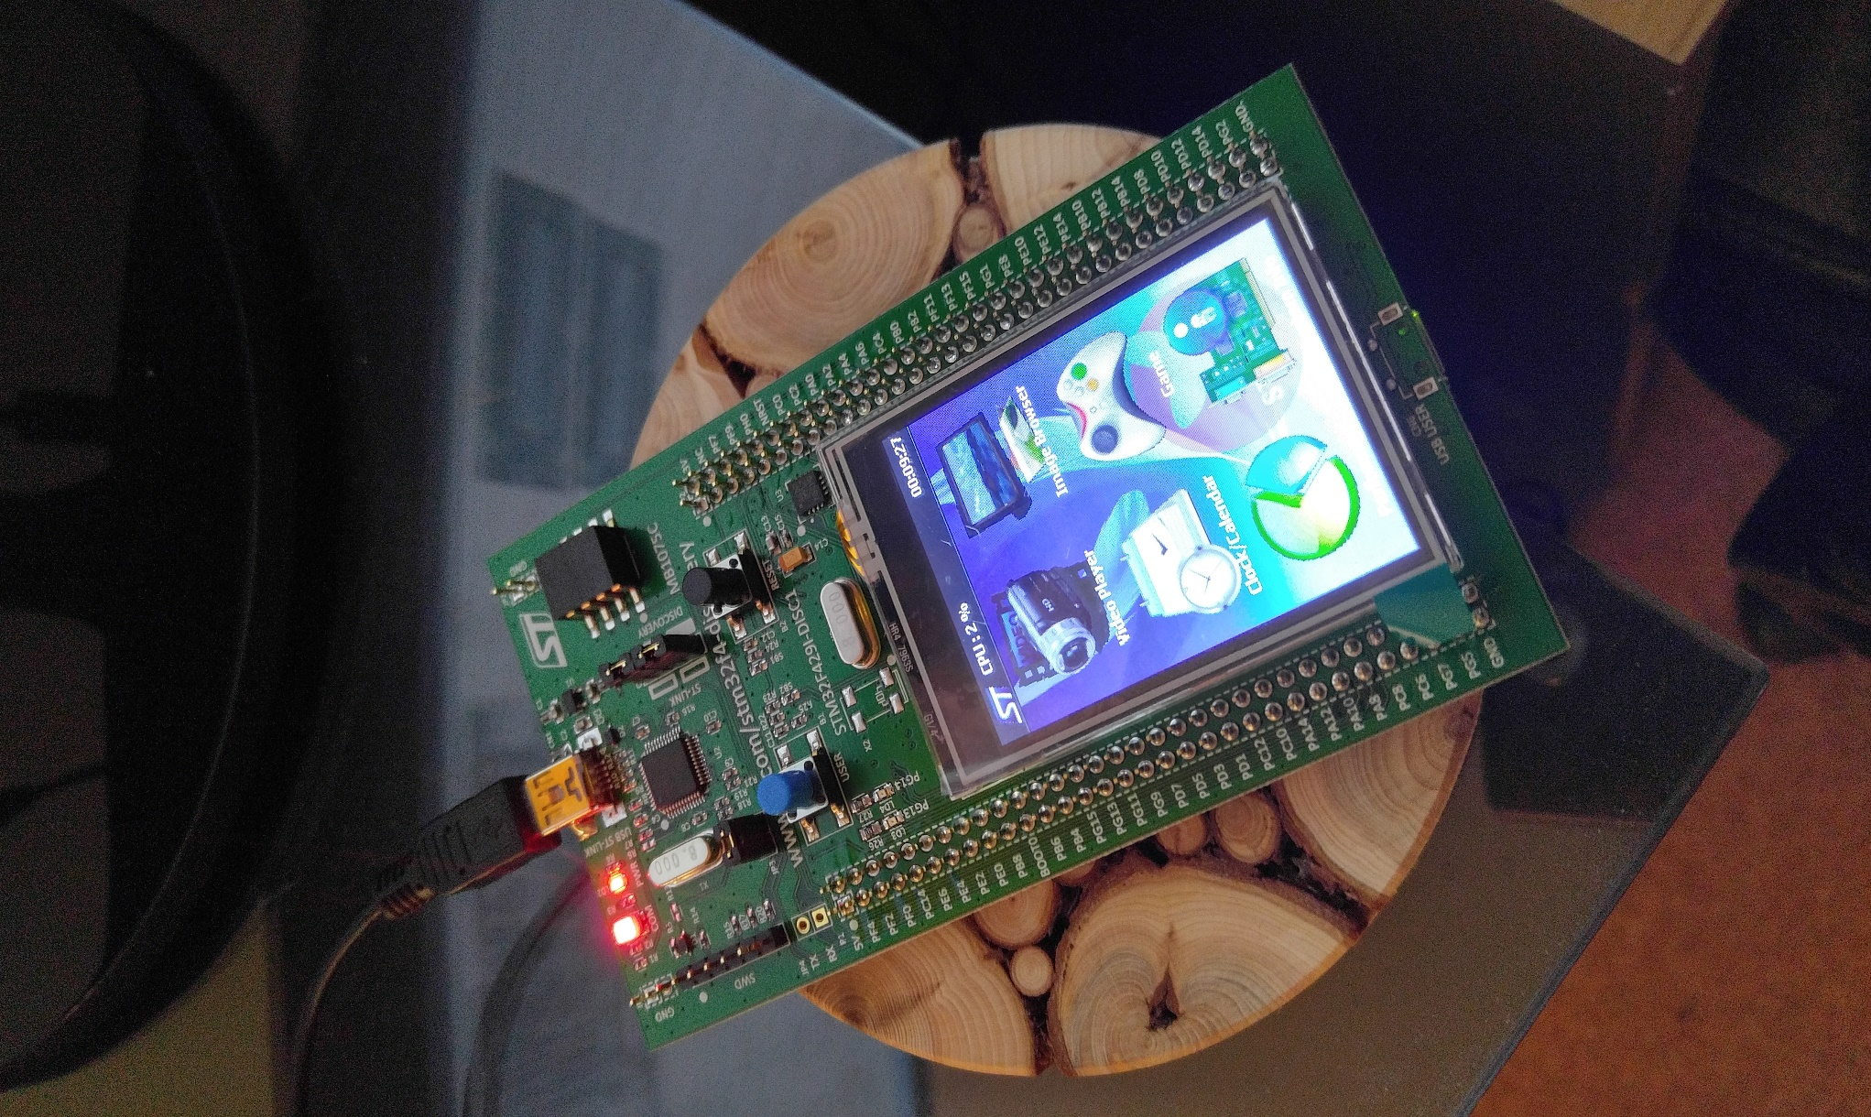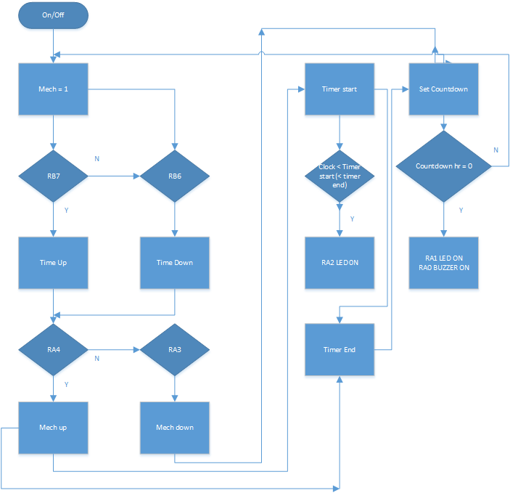The different mech's were set by using mech (mechanism) on the code, the user would have two buttons for moving up and down the mech's (M_D and M_U). The mech down function just allows the user to move one way through the mech's and mech up goes in the opposite direction. Then say when the user moves onto the clock function it is an accurate 24 hour clock that can have its time set by the user with two buttons. Time up and time down (T_U and T_D) and these will move either up or down in minutes on the mech. This digital clock was tested at the end of stage 1 and was shown to work 100% perfectly. As shown below on the test prototype board.

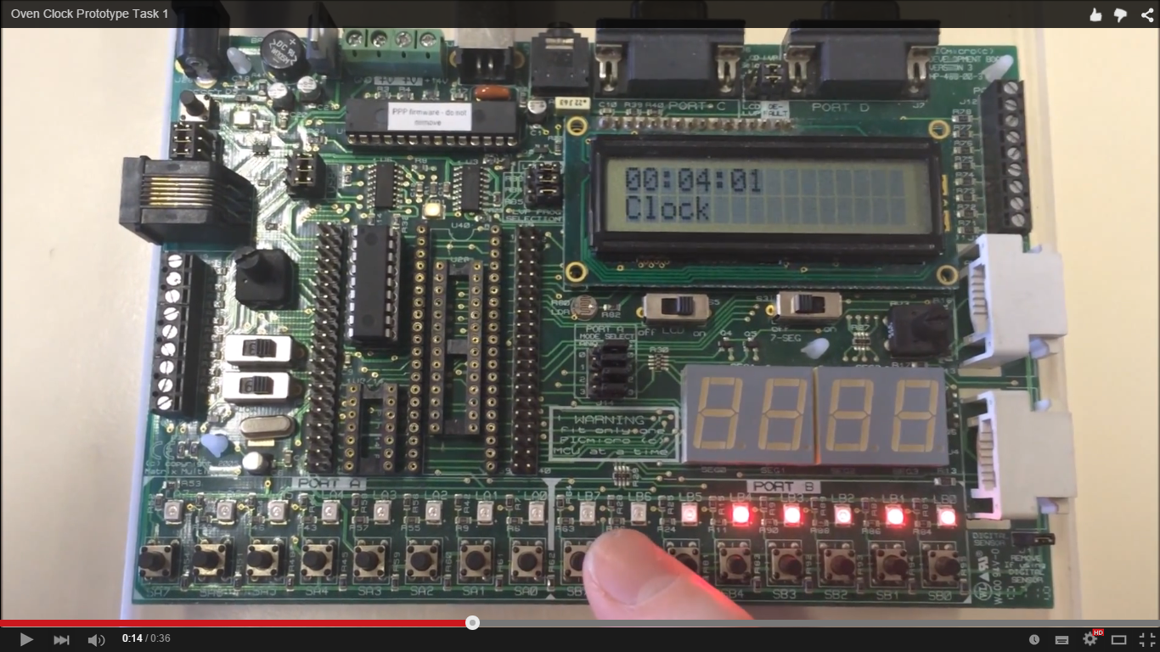

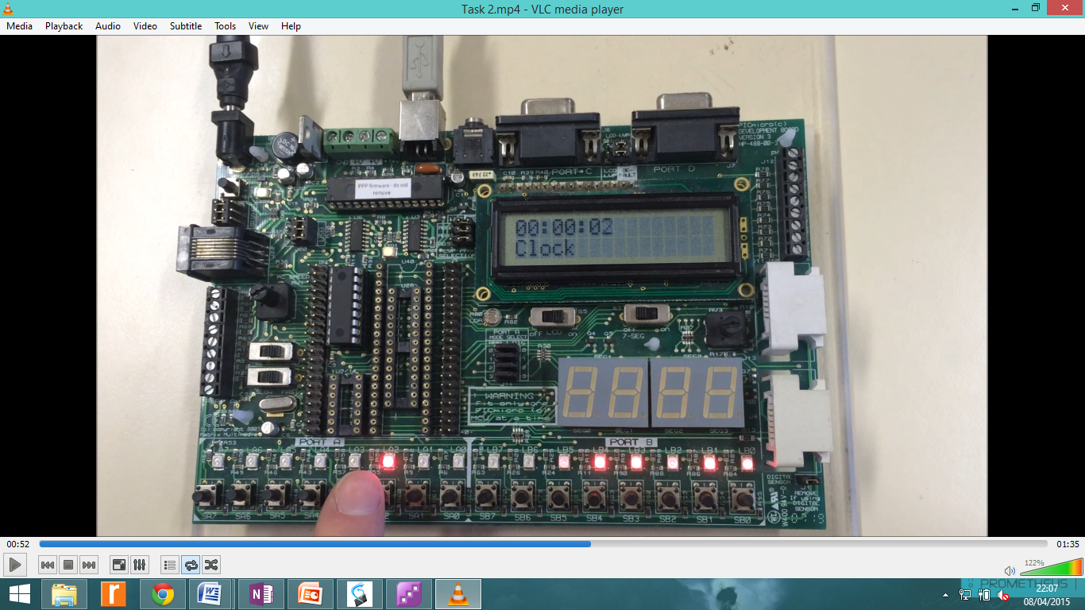Next up was the designing of additional features for the digital clock, now this stage had the percentage of errors which will be explained in the section Problems solved. So below is images for the prototype displaying all the other mech's that were created, for the code when the digital clock is of a time that is between timer start and timer end then it is programmed to output a voltage to a LED on the controller board.

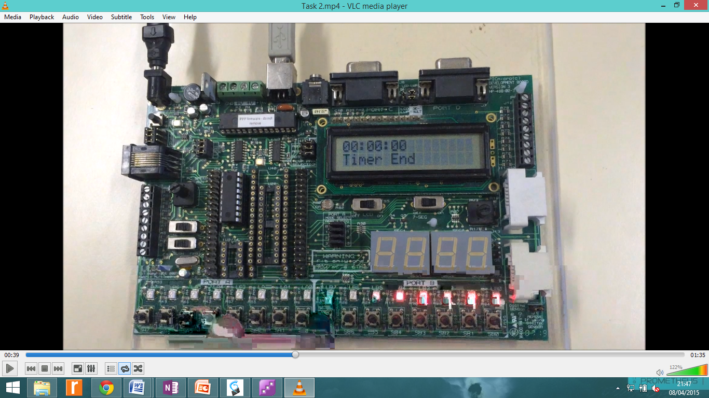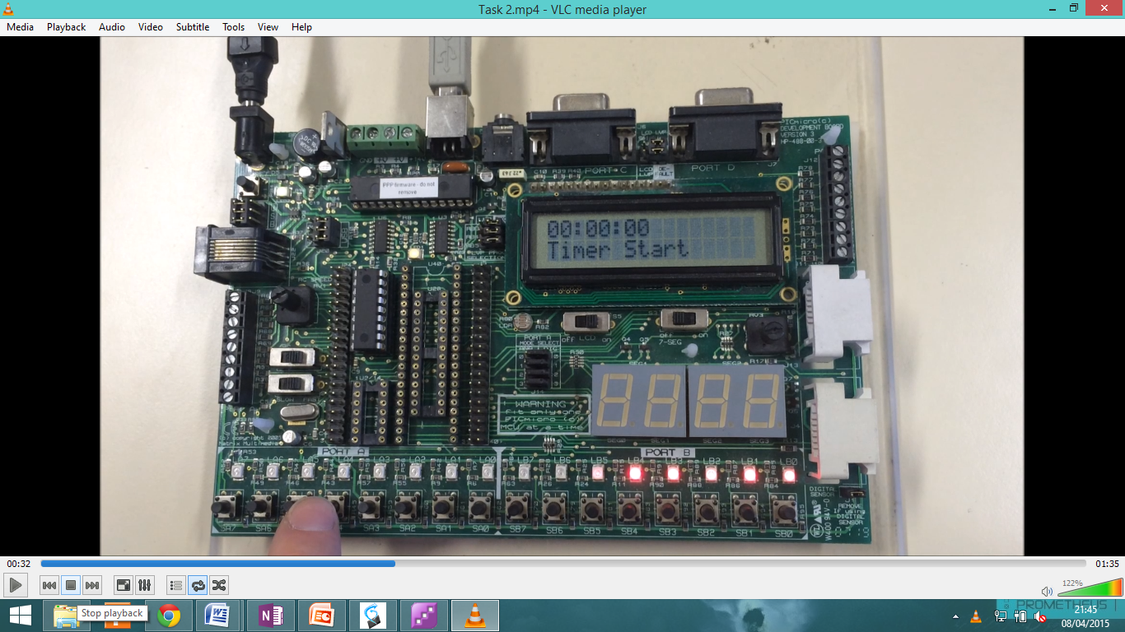This feature was inputted so that when the customer sets maybe a daily oven turn on and off times then when the time (clock) is between the times it will notify them with the LED. The clock has to be more than timer start and less than timer end for it to actually work. There are two other outputs on this board and they are on countdown function which is a little more complicated than the previous functions in its understanding. Countdown is set by the set countdown mech and it has its own clock function but it's just negative in counting, the countdown was set to between one minute and 5 hours and this mech has been inserted as Customers 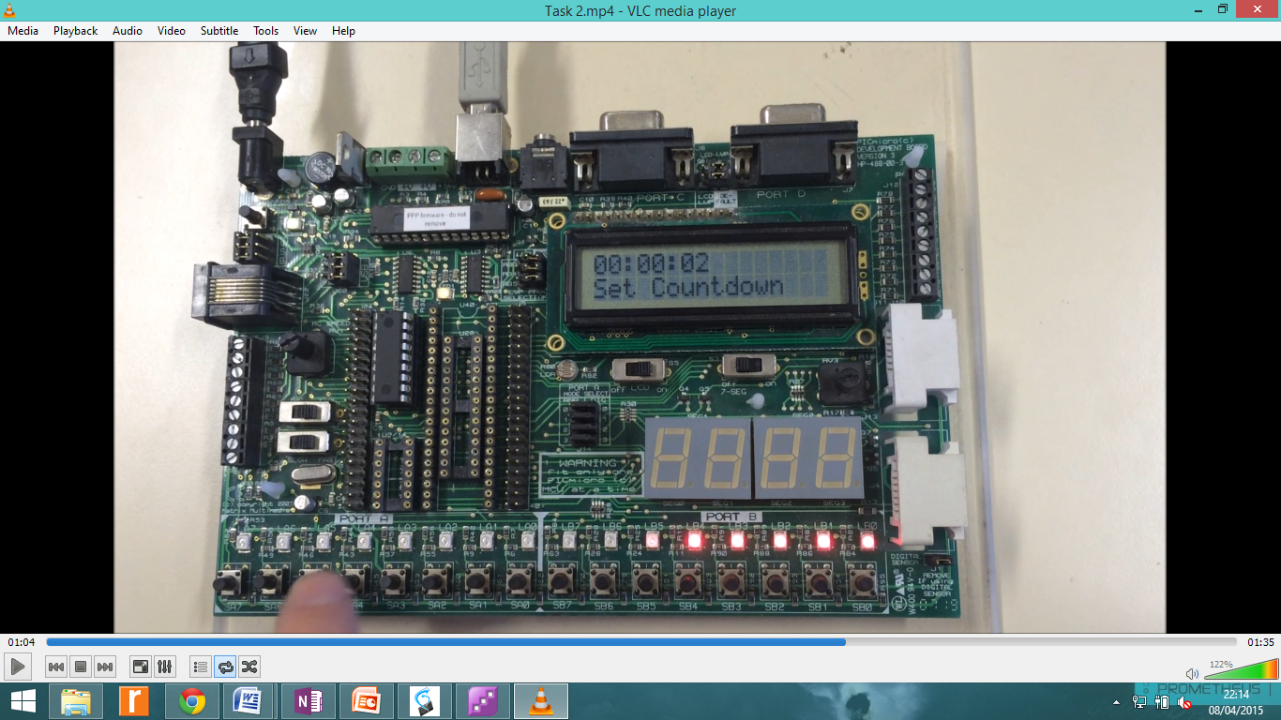when using oven's generally will either only want the oven on for a short amount of time and they don't want the hassle of having to check on it constantly so by being able to set it for a countdown of 30 minutes then heading off to do whatever other activity they need to do. Once that mech has reached zero then it will activate a buzzer and a LED, the reason an LED and buzzer 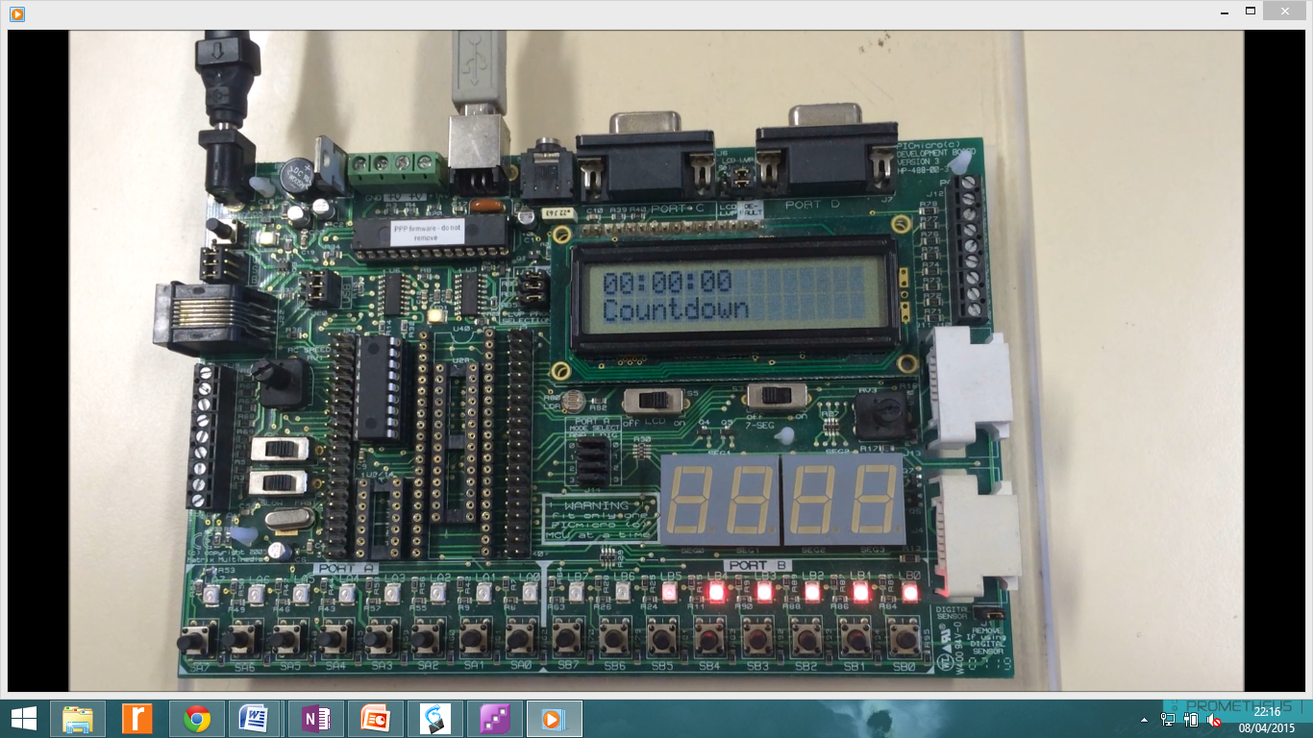were picked was because our customer could be deaf so having just a buzzer to alert them that the time is up would be too problematic.

As you can the 6th light from the left on the prototype board is lit up, this is for when the clock is between timer start and timer end. When countdown actually reaches zero we get the two outputs, this is the end of the code for this point as it really just has to be implemented into the schematic of the circuit and transferred onto the PCB PIC16F88.

# Proteus Design

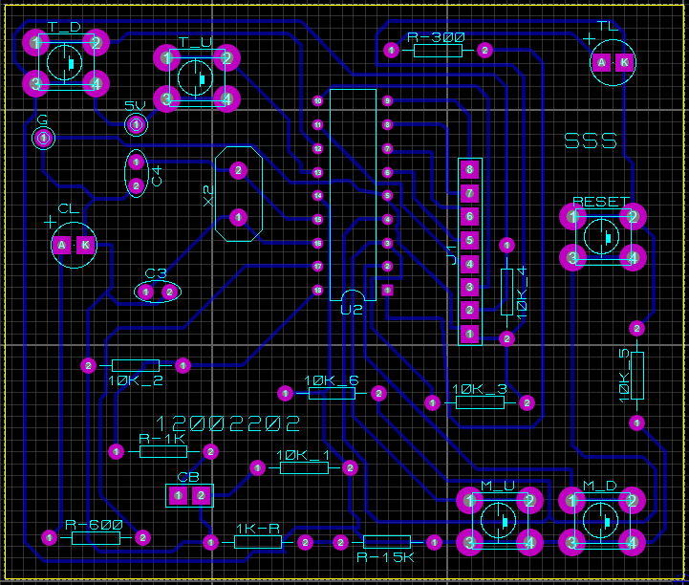  
In this section, what will be explained is the process of making a circuit schematic with the main focus on connecting the tactical switches for the end board to the PIC to send signals through the PIC to be displayed on the LCD. What was important was making sure that there were 5 tactical switches, the output components and the pull down resistors. Now with this very simple advice, it will explain how to connect components up to a PIC board to ensure they work, this was done through trial and error.

For when the PIC is receiving a signal on RA3 (M_D) then this is a input as it is not normally receiving any current on that port until the switch makes the connection and when that current is sensed on that port then the PIC will mech down and that will be displayed on the LCD. If it's an output port the LED or buzzer will be placed in series with a resistor to reduce the current sent to it. There is only current flowing through that port when the PIC has it set between certain parameters.

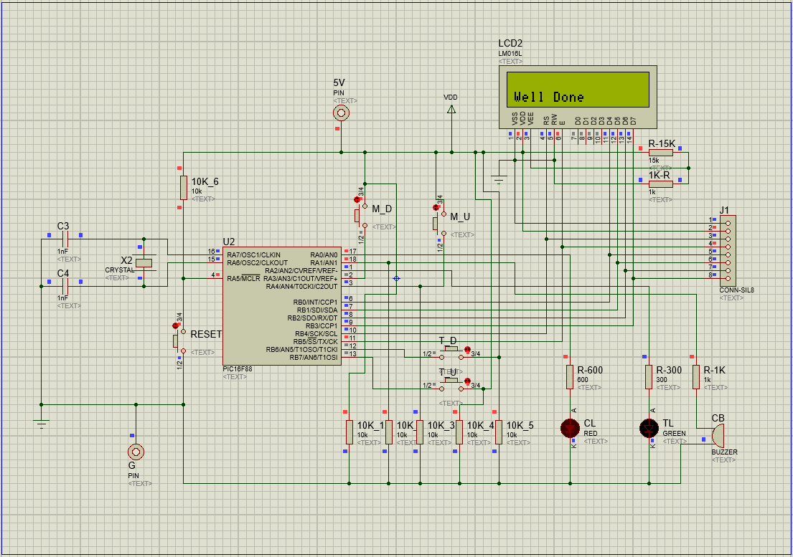On the schematic it states that the capacitor value is 1nF, this value is too large and for building the board it will be lowered to 15pF, this is a mistake that I myself have learnt from before in experience. The PCB was built using the ARES design on Proteus the furthest image in the section is of the finished board as when it was sent off. Next section is brief but it will explain how we built the board and if there were any faults when building it.

# Problems solved so far

For creating the schematic diagram, the problems encountered were really just a few mistakes. First of all, the green LED for Countdown mech on Pin RA0 began by always lighting up and the main reason for this was that it had been connected with power directly which should have been connected to just a resistor and the microcontroller pin.

Secondly, no resisters had been placed between the LED's and pins for the PIC16F88, it was also a necessary point to have lower resistance value than the automatically assigned 10k. Really the values shouldn't matter in the schematic as when building the board you can have any value but when actually building it you can change it to what you like. But due to the simulation being as real as possible the values had to be cut down to 1k and less resistance.

The last problem was the most important and this was the placing of 4 pins switch packages for the tactical switches, which should be 2pins for each pin. The most irritating problem that had happened with the schematic is the tactical switches placed themselves constantly on so input signals were always being sent and when pressed it would really confuse the LCD display.

To fix this dilemma replacement of the switches was needed and adding the switches with proper consideration that it was in the off position to begin with rather than just placing them in inconsiderately.

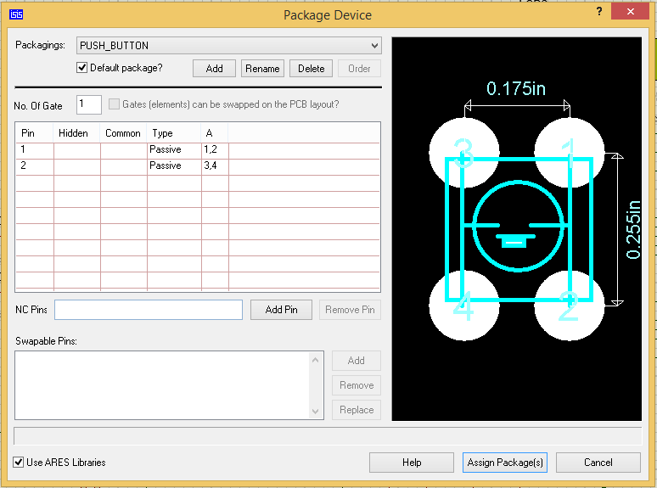

With building the PCB board on ARES software. The first is exclusion for the switch from the PCB layout as it was causing it to display error messages repeatedly. Then the trace style wasn't allowing us to change it to T20 which it must be to allow sufficient power to enter the circuit, the signal doesn't require T20 width of track only power. Thirdly, the placement of the PIC microcontroller component in the wrong mirror direction which inwardly inverted the pins, to really fix this solution you had to options either redo the whole design mirroring just that object or every single object.

When designing the code, constantly not adjusting for when the clock reached 24 hours at the start was a mistake so when entering what happened when the clock reached 24 hours, the programmer would just constantly increase rather resetting to 0 hours. This was fixed by just setting the clock time when it reaches 24 to 0. The mech down function was the most complicated problem in the whole project, so the mech function works that when RA3 port is pressed then mech decreases but this would work to a certain point it would move down through the functions but whenever it reached clock and it was pressed then it would freeze and the only way to get it back would be to mech up function.

So the clever solution to this is very simple, clock was named from the beginning of task 1 as mech = 0 so the mech down function was saying that whenever it reached mech = and it was pressed then it would move straight to the top mech but it's impossible to do that as mech = -1 was the value having to be inputted for it to understand when to go.

This couldn't work so the best thing to do would be too call clock mech = 1 instead and then also move every mech up 1 mech so that when mech = 0 it would automatically move to the last mech. Of course there is one slight problem with this approach and that's when the program is turned on because it automatically starts on mech = 0 so to again solve that a couple of lines of code were inputted. It states that when mech = 0 then mech = 1, now this could cause problems when using mech down but the testing of the board extensively wasn't able to find any faults with this part.

*if (mech == 0) //When mech = 0 then will automatically move to mech 1 for mech down purposes*

*{*

*mech = 1;*

*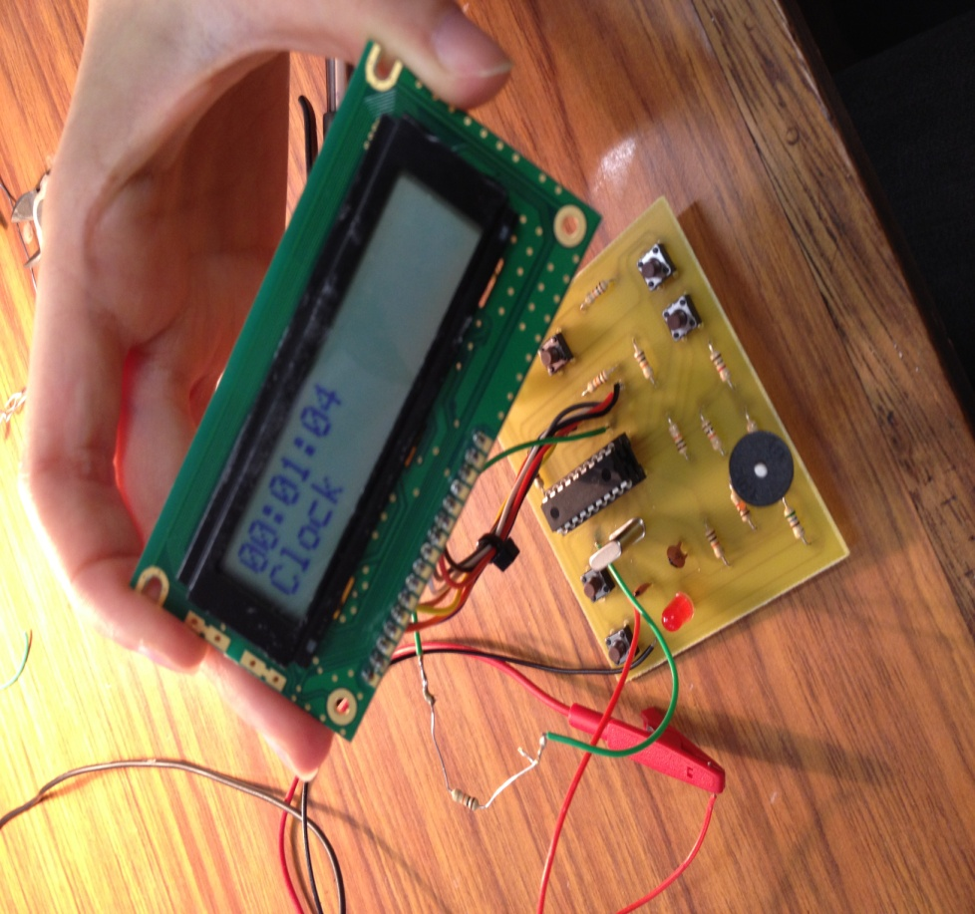 }*

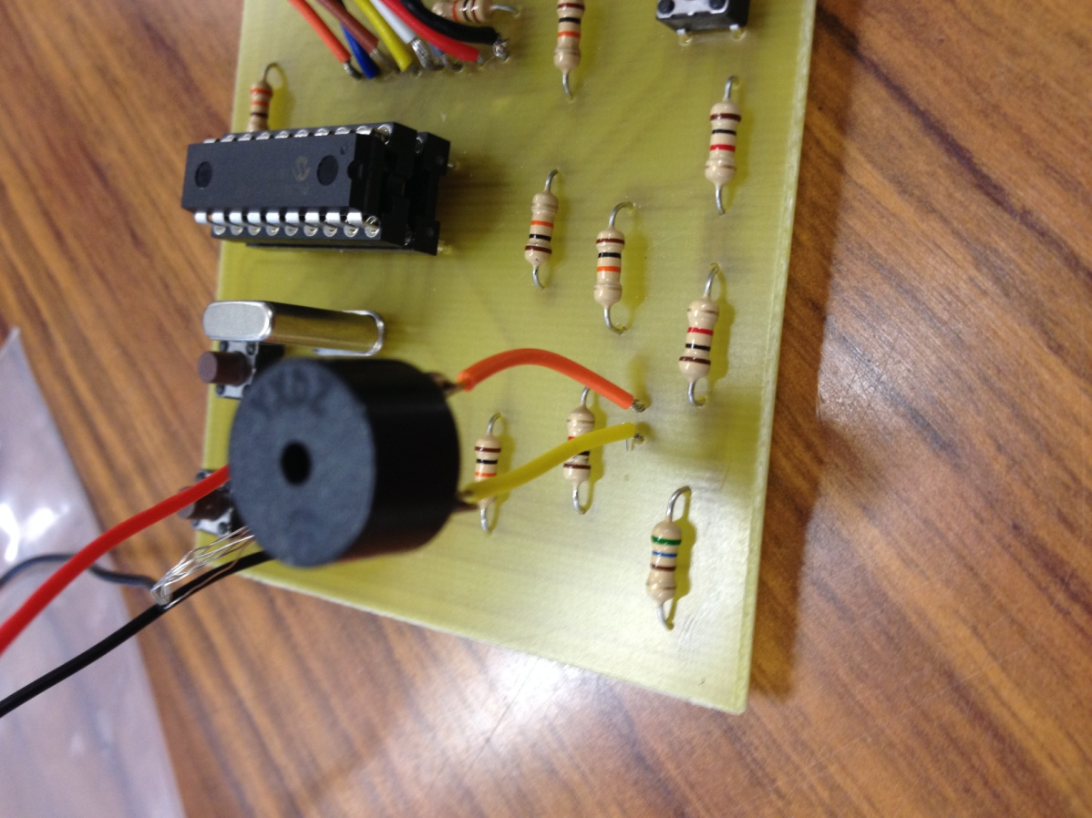

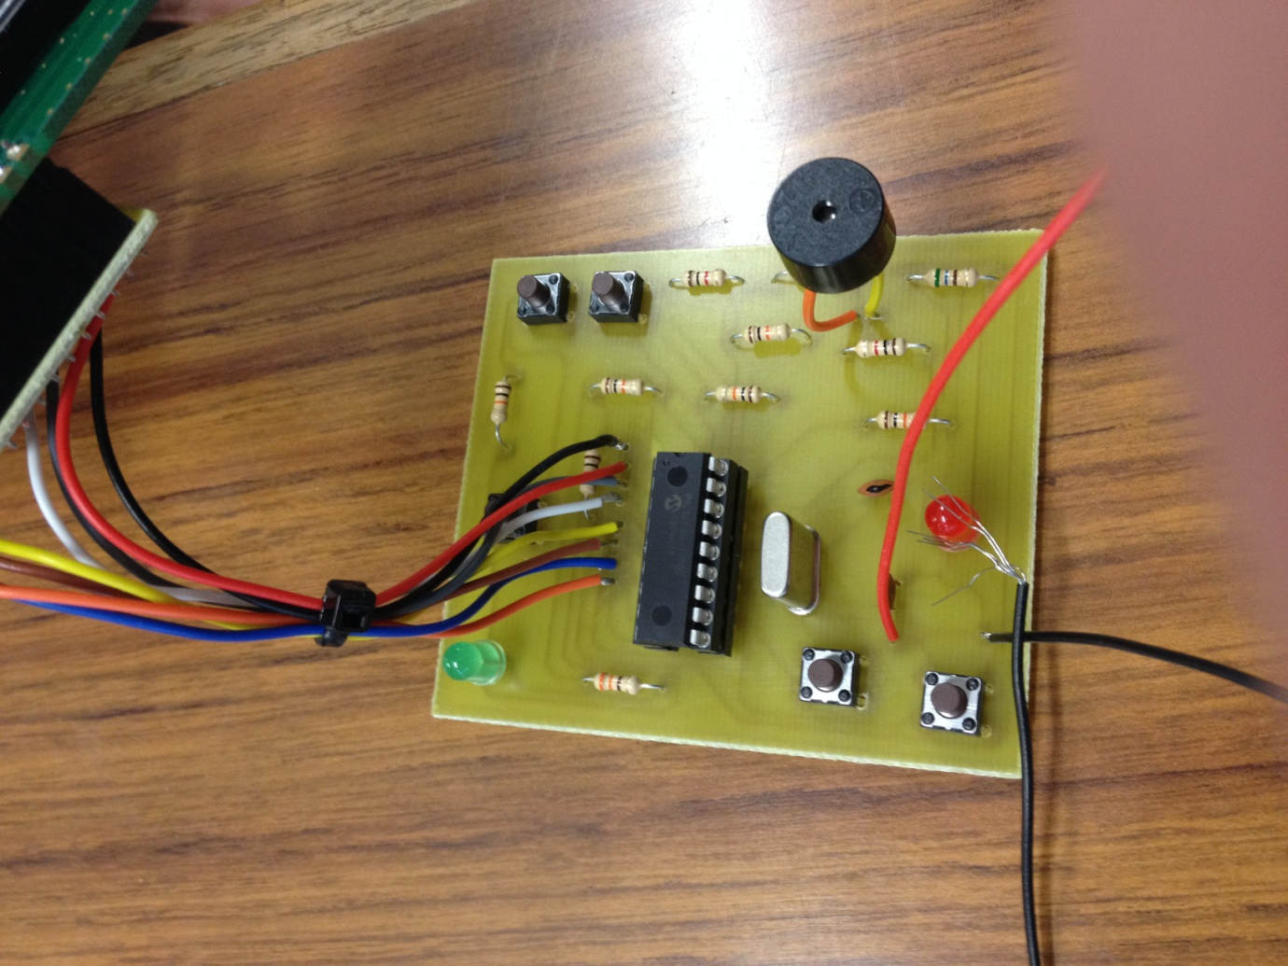

Next up was the building of the **PCB board** and this process has been completed many times before so we have experience in making it. But as many times when its being built, mistakes can still happen now building the board hasn’t taken very long and we worked as a team having everything laid out completely in terms of components so we could work efficiently. This part is being written at the end of the first three hour session and by this time we had built the board, meaning every part in its place and began testing.

What happened on the first test was that the LCD would not display any characters so it wasn't powered really. The problem here was I placed the eight wires for the LCD connector in the wrong way so power was on a data line and power was being sent through as data. When moving this all back round to the correct positions, it was found the Display turned on correctly then. I will now list the problems found with board that were design flaws and they will be matched by the colour circle solutions on the PCB image below:

* **Blue - Time Up jumping without button pressed**

After testing a few more times the time on every function was counting up a minute so quickly without there either being a connection made.

So time on every mech was counting up without the time up (T_U) button having made a connection so I tested to see if the button was actually connected in right and if I could do a short test on whether a 5V is being detected across it without it being pressed when the supply to the board is on. The voltage found was just short of 5V but this wasn’t good so we tested to see without supply to the board to see if there was a connection and there wasn't so the concept of floating must have occurred where the current has nowhere to go so it crosses the button and as there's supposed to be a 10k resistor (10K_4) connected to ground between the button and the PIC to stop the signal from entering the PIC completely. This wasn’t placed on the board; 10k_4 was connected on the other side of the board to ground.

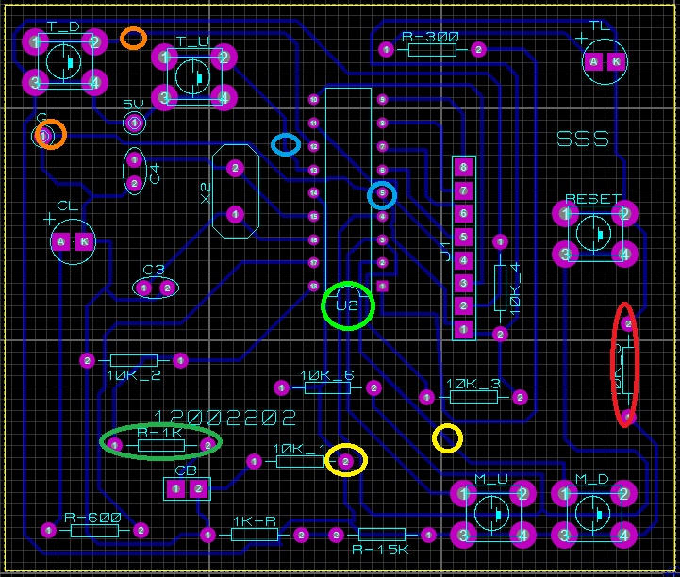So what was required was for us to place pull down resistor between the button and straight to the PIC, it would be grounded so that it makes sure the track was still there and not blocked. The current could be sent to ground and when the connection is made across the button then it would correctly increase the minutes by how many times it's pressed. When we made this change the me down (M_D) button located in the bottom hand corner of the board was now inactive than before we made this change.

* **Yellow - Placing the 10K-1 resistor on the mech down to PIC track**

This change was needed as mech down had become inactive when pressed and it was also missing a pull down resistor to ground so as 10k-1 was supposed to connect directly to mech down but where it was placed at the time before the change was making it useless so by moving the right side of it onto the mec down track and keeping that track, not cutting anything then it should allow it to work.

After coming back on the second session and then adopting this track change it is shown us that mech down now works correctly with no errors when pressed. What has happened that when on set countdown mech and by moving to this mech through just this switch it causes it to after a exactly 2 seconds every time to head straight back to clock. This was a new error and this point we had been making a few adjustments to the board there was a risk of damaging something too much with too many changes.

* **Orange - Fixing the time down error**

What was occurring now was two errors, the time would now rapidly count down with again no assistance in button connection, this problem caused the most damage to the board and it was the first real problem that we didn’t approach logically to, the top track above time down was cut by ourselves in a bid to fix this error and instead it was the track for 5V to the supply so whenever the button was pressed for time down then the LCD would switch on. Learnt the hard way here as a new link was needed between these track points. Next solution tried was to put a resistor on the track between the button and the PIC. This of course did not work because we needed the resistor to be a pull down to ground so clearly taking the time before making any permanent and potentially damaging changes to the board we added a brand new 10k Resistor in then connected it to the ground track. This wire connection was very untidy and had to be down on both sides of the board to stop any problems including shorting the board if the wire touches another track. This did stop the problem of it counting down without being pressed and hence decreased the list of issues to address.

* **Red - Reset Problems**

This board was a pain and the next issue was that when reset was pressed it caused the Timer Light to turn off but any other time it would be lit. This really wasn't a problem that was simple at first but the main problems here could be a short circuit, unnecessary connections or PIC failure. Now I removed the 10k-5 resistor that is circled in Red as it doesn't need to be placed there and instantly it stopped the timer light from being lit without the settings being changed.

* **Blue - PIC Failure**

So once the resistor was removed the board had an error where on timer end mech it was sending the data too fast to the PIC and the mech s were just not right as each time it was tested they started at negative times and so it kept breaking out in zero's. This gave Seulah the idea that when testing the PIC in task 3 the code was out or the PIC damaged then it would normally cause this error so we tried re-compiling the PIC and on the Source Boost code it stated that it couldn't be programmed due to faults when tested on the prototype it showed the same problems as on the PCB board so it was the problem at this point so we replaced it with a new PIC. From compiling this new chip it tested successfully with none of the previous errors on the former PIC. We then for the final time tested this and it worked 100% like expected. Every mech we could move to without it reverting back to Clock mech, the time up and down function was only active when we activated it, the timer light worked when the parameters for timer start and timer end set correctly. When the set countdown mech was on 2 seconds then on countdown it counted to zero then displayed the well done screen and both buzzer and countdown LED worked.

Any extra issues were that the buzzer was too quiet so looking at the data sheet for this model we had too high of a resistance before it so we lowered it to the preferred value of 470Ω and not 1k. This dramatically changed the sound, the last part was the cleaning up of the board making sure wires were short to avoid damage and also for ease of access to stop short circuits.

This is the final image of the board below.

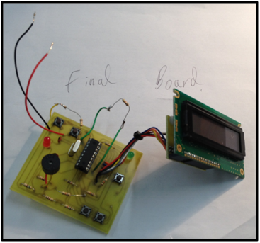

**Achievements**

**Future Improvements**

In order to make this section relatively simple, all improvements or recommendations for future production of this product are listed below:

* A protective case for the LCD, to stop users from damaging it.
* Light for LCD screen when needed.
* Ability to control temperature on the same panel.
* Internal memory to store preset countdown values.
* Ability to change between 12 hr and 24 hr clock.

**What I have learnt from this Project?**

I have gathered a great deal of skills from this project; I have understood how input and outputs work on the different pins of a PIC and their relevance. I have also got a much better grasp on how to program a clock function via the Sourceboost system, and also some of the ways to that can be exploited. Working in a small team and all working together but on different tasks was excellent and ensured that we all learnt each part but didn't take as long and could finish quicker. I have used ISIS and Proteus many times before but what I really furthered my knowledge on was the understanding of pull down and up resistance in accordance with output and input signals.

From building the board from scratch and designing each part, the flow code, the source boost code, the schematic and the PCB. I have each discovered these unique problems but also found good ways to fix them and move on. With my board working exactly as expected, it's been a thrilling experience where especially with the amount of errors on the board to think logically about what needs to be done without damaging the board was something I will always take away with me.

Never giving up and rather than it be an embedded systems project, it becomes lessons how to fuse your skills from other modules into this one and really enjoy what your building.

**Conclusion**

All in all this project has been quite successful, from completing the software side with considerable new features added. I believe that by adding a mech up and down function, this board has a even better ease of use and that the customer who will eventually be using this product will use the function regularly. Even though there were problems in developing this feature, I gained great deal of experience from fixing these errors and allowing the board to work. From the final testing of the programme on our own board, the board worked with many issues but from extensive experience and my knowledge of this board I was able to think through the problem to find the solution or solutions, I know that there were mistakes in building it but I have taken so much more away from this then if the board had worked properly to begin with.

What I really think worked well were the features that we included, especially mech down and up, the reason behind these features being our favourite inclusion is that if a real customer was purchasing this product and that's who we have to suit this for then they would enjoy being able to flick back and forth between the mech's. The mech down was a hassle included but the fact it was easy for the customer to go back a step rather than to continually moving up in mech's and eventually hitting countdown where it would have the buzzer and LED light up. So when the point of it always using set countdown skipping countdown was the best solution to make sure it avoided any annoyances.

When testing the PCB, it was necessary to after the problems solved to clean up the board by shortening connections and cutting any shorts out, after final testing the last problem that occurred was very frustrating that my only regret would be the ability to redo the PCB and start over as from all changes it has caused a major short to happen on the power and ground tracks so that had to be cut but this last problem is a result so redoing the board cleaner would be the last thing but overall this module was very successful and I have learnt more than I thought in this module.

## Appendix

## References

1 – Software Development Life Cycles - <https://melsatar.blog/2012/03/15/software-development-life-cycle-models-and-methodologies/>

2 – Waterfall SDLC - <https://www.tutorialspoint.com/sdlc/sdlc_waterfall_model.htm>

3 – V-Shaped SDLC - http://er.yuvayana.org/sdlc-v-shaped-model-design-phase-applications-advantages-and-disadvantages/

4 -